Stakeholder Register – Telco Cloud Migration Project

Project: Telco cloud project .

Date: May 2025

This Stakeholder Register identifies all key stakeholders involved in the Telco Cloud Migration Project.   
It includes their roles, interest and influence levels, communication needs, and engagement strategies. Understanding these dimensions ensures proactive management and alignment of expectations throughout the migration lifecycle.Detailed Stakeholder Register

|  |  |  |  |  |  |  |
| --- | --- | --- | --- | --- | --- | --- |
| Stakeholder Name | Role / Department | Interest | Influence | Power | Communication Needs | Engagement Strategy |
| James Kariuki | CIO / Executive Leadership | High | High | High | Weekly briefings, dashboards | Strategic alignment, executive updates |
| Miriam Odhiambo | Head of Network Operations | High | Medium | High | Bi-weekly reports | Change impact meetings |
| Peter Otieno | Project Sponsor / PMO | High | High | High | Steering committee meetings | Escalation & milestone reviews |
| Aisha Mwikali | IT Security Officer / Compliance | Medium | High | Medium | Security reviews, audit prep | Policy input, sign-offs |
| David Njoroge | Lead Cloud Engineer / Infrastructure | High | High | Medium | Daily stand-ups | Lead workshops, solutioning |
| Samuel Mutua | App Dev Manager / DevOps | Medium | Medium | Medium | Weekly syncs | Downtime planning |
| Lucy Kimani | Business Services Lead / CX | High | Low | Low | Periodic demos | Feedback collection |
| AWS Vendor | Cloud Service Provider | High | High | Medium | Weekly check-ins | SLA adherence |
| TelcoSoft Vendor | OSS/BSS Vendor | Medium | Medium | Low | Integration meetings | Certification support |
| Charles Wekesa | Change Management Lead / HR | Medium | Medium | Medium | Training updates | Adoption planning |
| End Users | Internal Staff | Medium | Low | Low | Training & surveys | Feedback sessions |

# Stakeholder Influence vs. Interest Matrix

This matrix maps key stakeholders according to their influence and interest levels, allowing the project team to tailor engagement strategies accordingly.

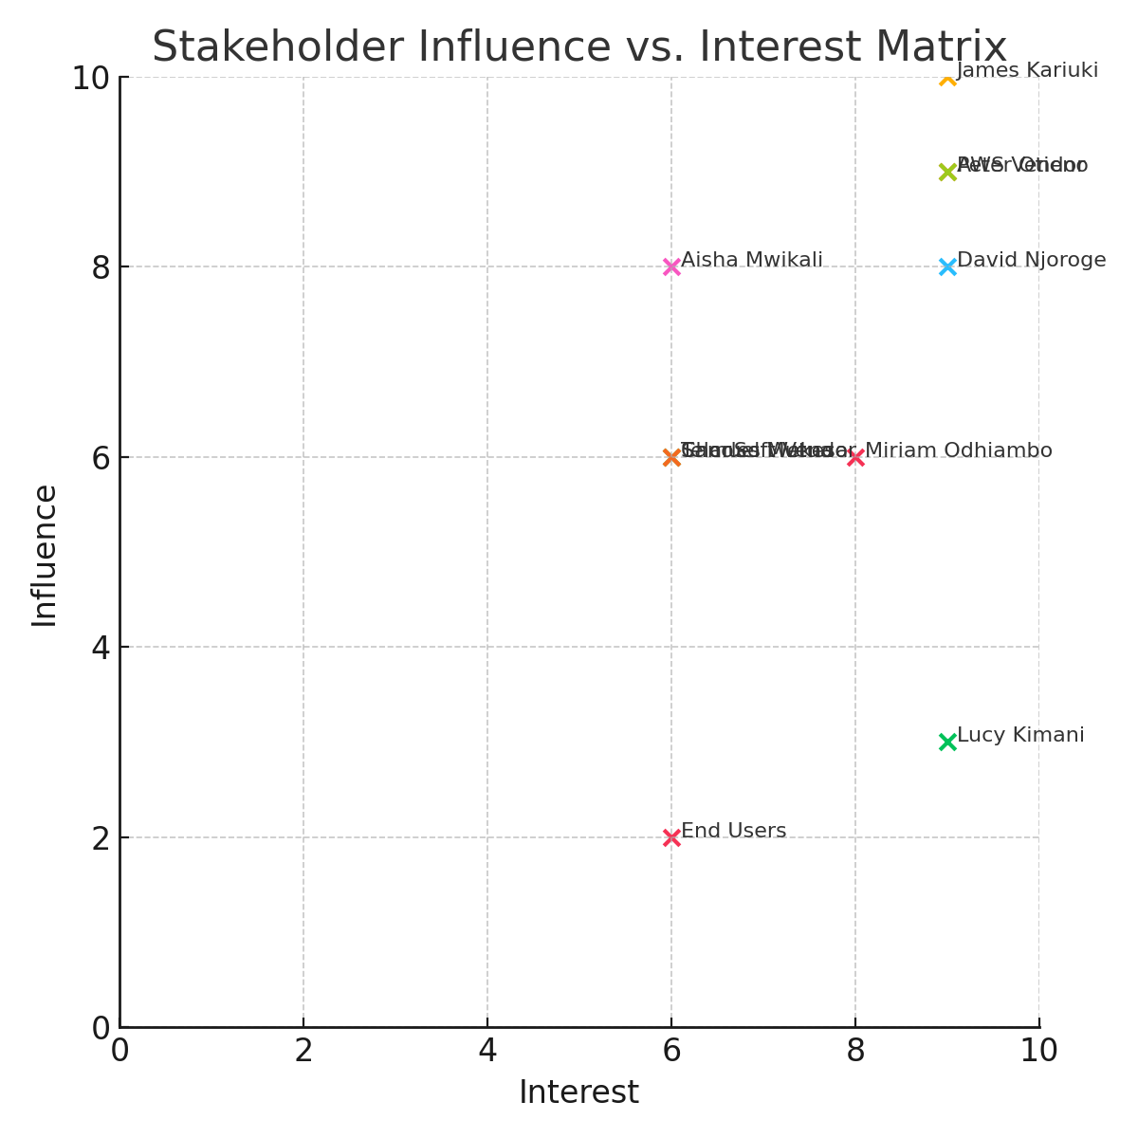

Stakeholders in the top right quadrant (e.g., CIO, Project Sponsor, AWS Vendor) require close management, while those in the bottom left can be monitored with minimal effort.